***AURA UNIQUELY DESIGN:***

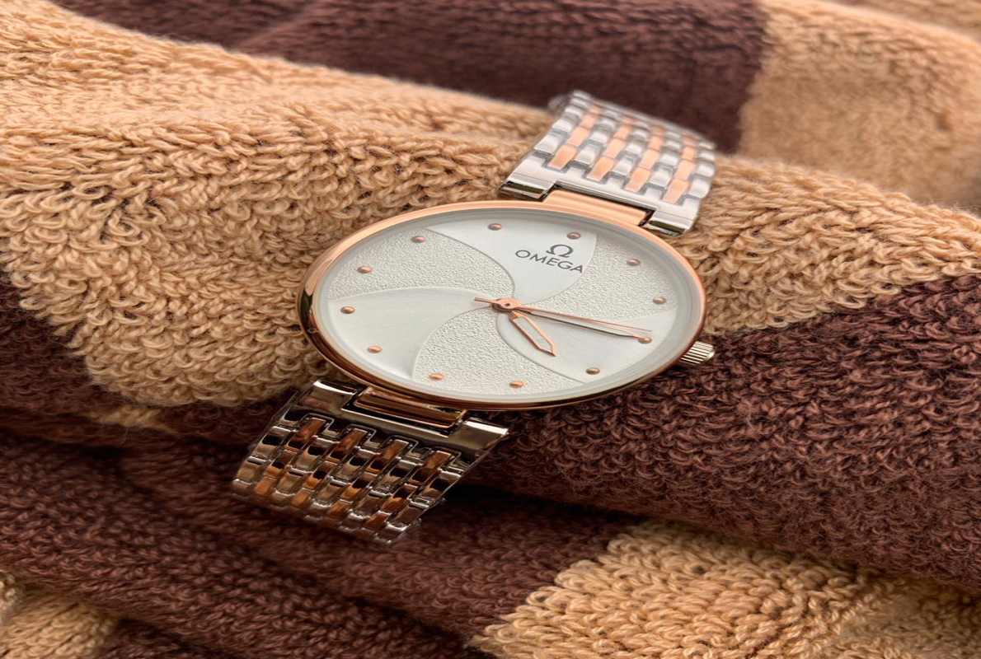

***DETAILS ABOUT THIS WATCH:***

Case Thickness: 7mm  
Case Material: Stainless Steel  
Dial Color: Rose Gold  
Movement Type: Quartz

***SPACES:***

**DIAL COLOR:**Rose Gold

**CASE SIZE:**28mm

**CASE SHAPE:roundCASE THICKNESS:**11mm

***Price***

***Rs:2,800***